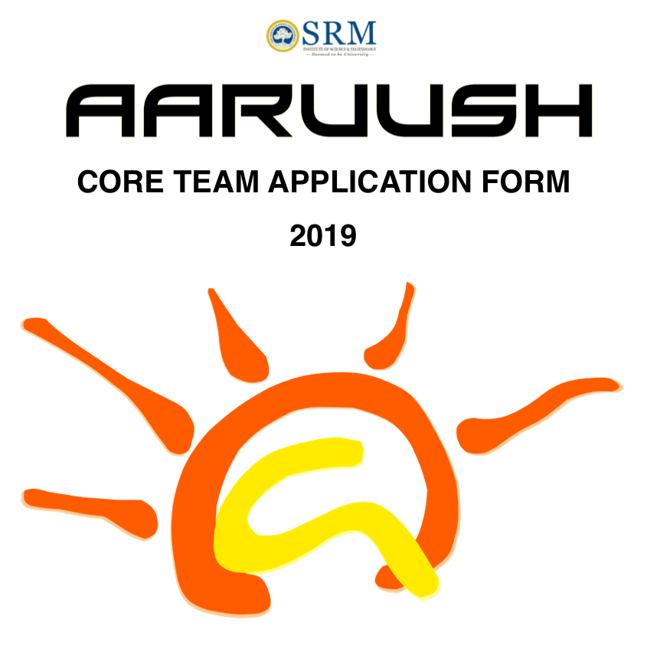

|  |
| --- |
| **Full Name: Arko Chatterjee**  **Registration Number: RA1611004010714**  **Department: Electronics and Communication Engineering** |
|  |

**Video Profile:**

1. Please record a **video profile** of yourself lasting not more than 5 minutes and not less than 4 minutes long.
2. The video should contain the following details-
3. Self-Introduction: (30 seconds)
4. If you were a student leader, you would... (2 minutes)
5. Why do you wish to become an Aaruush Organizer? (30 seconds)
6. Where do you see yourself 10 years in the future? How will Aaruush impact your life? (1 minute)
7. PLEASE SAVE THE VIDEO FILE AS YOUR FULL NAME.
8. Upload the video on to a private channel of YouTube with open permission and submit the link along with completed form.
9. Also mail the link along with subject as Name, Registration Number and Contact number to [convenor@aaruush.net](mailto:convenor@aaruush.net)
10. Two Letter of Recommendations from any 2 Organizers of AARUUSH’18 in the format given at the end need to be submitted.

(Note: The Letter of Recommendation form has to filled manually by taking printouts.)

1. Form needs to be **typed in digitally** and finally printed.

**Name: Arko Chatterjee**

PASTE YOUR LATEST PASSPORT SIZE PHOTOGRAPH

**Registration Number: RA1611004010714**

**Gender:** Male

**Year: 3rd Year**

**Department:** Electronics and Communication Engineering

**Email ID:** [arkochatterjee@gmail.com](mailto:arkochatterjee@gmail.com)

**Mobile Number: 8902067083**

**Day Scholar (Yes/No): NO**

**Link for YouTube Video Profile:**

|  |  |  |  |  |  |
| --- | --- | --- | --- | --- | --- |
| **SEM** | **I** | **II** | **III** | **IV** | **CGPA** |
| **GPA** |  |  |  |  |  |

1. **About myself: (20 words):**

I’d love to call myself a big foodie person who constantly have a knack for trying out anything new. Apart from that, I’m almost engrossed in learning something new each day!

1. **Goals and Ambitions for life:**

My **Ambition** is to be become a influencer in whatever field I work in or I intend to work on future, such that you don’t have to introduce yourself to others.

For the current future, my Goal is to excel in my field of academics and research primarily in my field of Internet of Things and Artificial Intelligence, publishing papers and securing patents in the same. Hence, my next step is to apply for integrated MS+PhD Programs in various Universities.

1. **Plan of Action to achieve the same (mention your course of action in points):**

* Currently working on various Research Projects under couple of faculties in SRM to facilitate my goal for higher studies wherein I’m primarily focusing on publishing papers.
* Preparing for GRE (Graduate Record Examination) which I’m planning to give during late December or early January.

1. **SRM Institute of Science and Technology -**

* **I admire (3 qualities):**

1. A Campus having students from all across the country which gives everyone a rich cultural knowledge to all!
2. There are various opportunities in SRM-IST for student who asks for it. (Yes, I’m a Potterhead)

* **I dislike (3 dislikes):**

1. Teacher to Student Ratio is very high when compared to other Educational Institutions, which hampers one to one guidance of the students
2. 75% attendance shouldn't be a criteria in any Educational Institutions
3. The University fails to support a student who get’s Research Internship opportunities to abroad Universities.
4. **About Aaruush (20 words):**

* **As a Viewer/Participant/Audience from SRM campus:**

As Audience of Aaruush from first year, I was ecstatic about the Techo-Management Fest preferably because I was a Core Committee Member of my School Fest during my last year of school and hence, the feeling of a fest and attending a fest was something I was always attached to. Over the last three years of attending Aaruush, I loved the ambiance and the enthusiasm of all the participants of the fest!

* **As a member of the Aaruush Team:**

As I’ve already mentioned being a Core Committe Member myself, I always had a knack for doing something for the fest and that wish came to me as a blessing when I received a message over Messenger from my then CH Uday bhaiya who liked my Designs and asked me whether I wanted to join Creatives. Hence, commenced this amazing journey with Aaruush, truly making it not just a fest, but a feeling.

1. **My journey through Aaruush and what I’ve learnt from it   
   (Mention in points):**

* There no limit to learning and there’s definitely no hierarchy of learning.
* The learning curve is always proportional to time invested in the learning
* There will be failures, but then they are the pillars of success at the end of the day
* Being a good listener, be it from your juniors or seniors.

1. **What will I gain from working at Aaruush? (Mention in 3 points):**

* I have definitely gained my leadership skills from working at Aaruush
* From taking various classes from Android Development to IoT it taught me the skill and art of teaching.

1. **An instance when your personal willingness has improved your work performance in Aaruush? (Elaborate with an example)**

My responsibility in Aaruush primarily was developing the Android and iOS Application for Aaruush and the main driving force behind this task was my personal willingness because it was of this personal willingness which led me to learn Android Dev and implement it to develop the first Application developed by Aaruush!

1. **Ideas for change that I wish to make in Aaruush: (mention in 5 points):**

* Introducing more of the Tech Factor in the Fest.
* This can be introduced by implementing events like Hackathons, Open-Source Projects.

1. **How can I contribute towards improving Aaruush? (Mention in 5 points):**

* My contribution to Aaruush will be in any way possible but primarily relating to the technical side of the fest.
* The technical side includes development and maintenance of Applications and Websites which serves the purpose of branding Aaruush to the people outside SRM-IST.
* It also involves developing innovative and smart solutions to enhance various processes of the fest.

1. **Name one Event that would not have been possible without your contribution and explain how?**

I’ll share the work I did, without my contribution wouldn't have been possible. I developed the Android Application for Aaruush for last two editions and I’m proud to say that I developed the first in-house Android Application of Aaruush.

1. **Do you feel there can be unexpected hindrances during the fest? If yes, what are they and mention the course of action to handle them  
   (mention min 3 points or more):**
2. **Aaruush ’18 – Positives and Negatives (Minimum 5 Points, each)**

* **Positives:**

1. Being a Committee Head, it was the time I learnt the quality of leadership and motivating my juniors to work and strive for the best.
2. It was also a time, I felt responsible for the fest to the core, responsible for my actions, the actions of my juniors.
3. Aaruush ‘18 truly taught me the validity of the fact that Team work and coordination is the very important.
4. This Aaruush, taught me how important deadlines are. How important it is to finish modules of your project within deadlines so that it is a great success at the end.
5. One of the greatest thing I felt, is the freedom given in cases of innovation and finding smart solutions.

* **Negatives:**

1. It’s bit hard to get things approved from higher authorities from before. Everytime proposals are approved at the last moment which dosen’t give the full potential.
2. I’d love to see more technical aspect of the fest compared to the non-tech aspect of the same.
3. It hurts me when most of the 2nd and 3rd Year students don’t value the techno-management fest of their own college and looks down upon Aaruush.
4. To be specific about Aaruush ‘18, it failed to attract many students compared to the previous editions of Aaruush.
6. **My next steps after I am selected/not selected as a core team member:**

* **If selected: (Mention your course of action in points)**

1. First and foremost, I’d bring forward ideas and strategies for making Aaruush, a more technical fest by implementing projects like Hackathons and introducing Open-Source Projects which will engage a large number of students.
2. Then would be development of existing Android and iOS Application and making it more prone to user engagement.
3. Automate all workflow in Aaruush, like it was implemented in A’18, but failed due to last minute changes by the authorities.

* **If not selected:**

1. Even if I’m not selected, I’d always promote the idea of conducting a Hackathon and Open-Source Projects if I have the backing of Aaruush.
2. In this scenario,I will dedicate my time more towards research and development in the field of IoT and AI
3. **How can team Aaruush grow beyond a techno-management fest in enriching and integrating technology into campus life at SRM?  
   (Mention in points and explain each point)**

* Likewise I mentioned, conducting events like Hackathons and Open-Source Project is one the best ways of not only integrating technology into Campus Life but also will be a learning and teaching experiences for all
* Hackathons and Open Source Project – provides a platform for all to learn about what hackathon and what Open Source Project means and at the same will portray Aaruush as a Technical Organization.

1. **Name an Event/initiative/campaign/activity conducted by Aaruush that could take Aaruush to greater heights.**

The initiative of Hackathons and Open Source Project which provides a platform for all to learn about what hackathon and what Open Source Project means and at the same will portray Aaruush as a Technical Organization, hence promising Aaruush to greater heights not only in Chennai but in India.

1. **Mention, if any, the events that you have participated in, outside SRM:**

I’ve participated in various Hackathons namely:

1. SRM IET Hackathon
2. Mozilla Hackathon
3. VIT Makeathon
4. Accenture Blockchain Hackathon in Bangalore

and also couple of conferences :

1. GDG Dev Meet ‘18 and many more.
2. **If yes, how are they different from Aaruush– aspects of techno-management fests? (Mention in Points)**

* As per say, I did’nt quite participated in a fest, but when compared to the other events, I’d feel Aaruush is a time when everyone enjoys to their hearts content.
* One Factor I feel that can be improved is the involvement of every single individual of SRM, which happens in other events I’ve attended.

1. **Aaruush has been ever expanding, how will you make sure Aaruush reaches the farthest corners of the country? (Minimum 3 point)**

* First and Foremost by introducing events like Hackathons and Open-Source Projects which surely augment Aaruush to reach the farthest corners of the country.
* I believe it will take time, but two/three years down the line, we can expect people from the farthest corners of our country will know what Aaruush is.
* Branding is the most important factor which determines the reach of Aaruush and the digital platform is THE factor which augments the branding of Aaruush. Hence, with developing state of the art Mobile Application and Website we can ensure that the name of Aaruush reaches the farthest corner of the country.

1. **Ideas to increase the technicality of Aaruush: (Minimum 5)**

* Automate all workflow of Aaruush
* Generation of E-tickets and unique IDs
* Same goes with Workshops, Accomadation.
* User Engagement with the Aaruush Application
* Implementing concept Centralized Portal wherein we track down all Events happening around the campus in Real Time.
* Implementing a Portal wherein proposals can be laid and it can be put to vote according to hierarchy or any logic previously provided using concepts of Decentralized Database and Blockchain.

1. **Committees/ Domains have evolved greatly over the years, do you feel any change is required? If yes justify**

Being in Creatives since my 1st Year, I must say Creatives has evolved in every way possible being the unofficial Technical Support team for Aaruush from designing banners to clicking and processing photos to rendering such breathtaking videos to developing state of the art Mobile Applications and Website.

I’d feel there’s no change required, but to produce the best quality output in the years to come.

1. **Best moment(s) in Aaruush: (Minimum 3)**

* My own Android Application to be uploaded to Play Store which had around 3000 download in Aaruush ‘17.
* The next best moment was when Aaruush ‘18 Application became the 7th Trending Application in Play Store within a day of launch.

1. **Lowest moment(s) in Aaruush: (Minimum 3)**

* It was when Aaruush ‘17 App had overflow of negative comments as the other team’s app was not approved.

1. **Best moment(s) of my life at SRM: (Minimum 3)**
2. **Lowest moment(s) of my life at SRM: (Minimum 3)**
3. **Groups/Organizations in SRM that you are currently working (OR) have worked**

**before (Specify):**

* **Name:** WisOpt **Your post:** UI/UX Designer  **Duration that you are/were associated with the group:** 4th Semester **Description of your post (20 words):** I was responsible for desinging UI/UX for Android and iOS Application of WisOpt
* **Name:** WebArch **Your post:** Lead IoT Researcher  **Duration that you are/were associated with the group:** Still Associated **Description of your post (20 words):** Responsible for IoT Research in WebArch

1. **People Run Organizations or Organizations run People. Write pros and cons.**
2. **If given a chance would you like to be part of ‘Team Envision’. (Yes/No)**

Yes, I was a Committee Head for Team Envision.

1. **If yes how will you be able to contribute to Team Envision?**

Likewise I’ve mentioned previously, my ideas I wanted to implement is exactly what Team Envision does. Since, the unofficial motto of Team Envision is to make Aaruush more technically sound, my expertise and my ideas perfectly syncs with that of Team Envision

1. **Something that I wished for in Life, but couldn’t achieve:**

I longed wished for mastering the art of writing, but till now was not able to master it. I always looked upto my grandfather who was writer and so wanted to be like him.

1. **As my social responsibility, I have undertaken:**

As far as social responsibility I contributed to the society by helping out an Old-Age home by cleaning the tables and chairs, interacting with the aged people and contributing funds collected from my neighborhood and schools over a couple of occasions during my school life.

1. **Do you blend in or stand out? Justify**

I prefer to blend-in and thereafter providing my stances so that everyone tends to follow you happily. It’s so because, I feel if you stand out and expect something to happen, or something to be completed, your peers or your juniors either move forward with you or not, with which your end product will not be what you had envisioned.

1. **Responsibilities undertaken in School/before College:**

* Secretary of Cyber Spcae Group – the Coding Group in my school
* School Tech Team Member – Android Developer
* Class Monitor
* Class Captain

1. **Achievements/Awards:**

* 2nd Position at IT Quiz, Computer Society of India, Kolkata Chapter
* Special Mention at SRM IET Hackathon
* 3rd Position at Mozilla Hackathon
* Special Mention at Accenture Blockchain Hackthon

1. **Hobbies:**

* Love to play Harmonium
* Playing around with IoT, Electronics devices
* Swimming
* Table Tennis

1. **Areas of interest (Technical & Management):**

* Java
* Android Development
* Python
* Firebase
* Django/Flask
* Machine Learning
* Deep Learning
* Computer Vision
* Internet of Things

1. **My plans for fourth year:**

My primary motive is to give my GRE, start applying for CS related programs at various universities and publish a paper at a renowned conference.

1. **With respect to research/project:**

* I have already worked on a research during my internship at IIT Kharagpur which will get published at the end of this year.
* Currently I’m working under two faculties of my department and working in various projects which includes IoT, AI and Computer Vision.

1. **With respect to higher studies/placement:**

My primary aim is to pursue higher studies as I’ve said, I am more inclined towards Research and Development. With respect to it, I’m currently working under two faculties of ECE Department which will provide me the opportunity to publish some amazing papers at renowned conferences.

**References from two faculty members (one must be Class Incharge-with signatures):**

|  |  |  |  |  |
| --- | --- | --- | --- | --- |
| **S.No.** | **Name** | **Dept.** | **Mobile & Email** | **Signature** |
| **1.** |  |  |  |  |
| **2.** |  |  |  |  |

**References from two Organizers (LOR) :**

|  |  |  |  |  |
| --- | --- | --- | --- | --- |
| **S.No.** | **Name** | **Post** |  | **Signature** |
| **1.** |  |  |  |  |
| **2.** |  |  |  |  |

**Date:**

**Form and video profile should be submitted on or before 3rd October 2018 to Dr. A. Rathinam between 12: 30 PM to 1:30 PM on weekdays at ESB 201, Main Campus, Department of EEE.**

Contact if any query:  
Animesh Verma, Secretary: +91-9029074747

Anmol Mishra, Joint Secretary: +91-9884209403

**Declaration:**

I hereby declare that the details furnished above are true and correct to the best of my knowledge and belief and I undertake to inform you of any changes therein, immediately. In case any of the above information is found to be false or untrue or misleading or misrepresenting, I am aware that I may be held liable for it.

Signature:

**Terms & Conditions:**

**Aaruush** shall be considered second to **Academics.**

The selected core members will have to **dedicate** wholly for the conduction of Aaruush’19. It is also **mandatory for them to stay back during both vacations for Aaruush work**.

If selected as an Organizing team of Aaruush, it is **mandatory not to leave the team** until the completion of Aaruush tenure of one year for **any expected or unexpected reason**.

Shortlisted candidates **should be available during the month of October & November** for the completion of the selection process.

To, Date:  
Dr. A. Rathinam  
Convenor,  
Aaruush,  
SRM IST.

Respected Sir,

**LETTER OF RECOMMENDATION**

It is with great pleasure that I write this letter, recommending

Mr./Mrs.__________________________, Branch_____________________, Registration No. __________________ for applying to the post of Organizer of AARUUSH’19.

(Rate the Individual on a scale of 0-10 and illustrate an instance in a few sentences to support the rating given.)

1. Honesty:

1. Trustworthy:
2. Leadership:
3. Initiative Taker:
4. Creativity:
5. Domain Knowledge:

1. Dedication:

1. Positive Attitude:

1. Communication skill:
2. Responsible:
3. Discipline:

1. Adaptability (In Crisis Situations):
2. Commitment:
3. Punctuality:
4. Professionalism:

**Contribution towards Aaruush ’18** (mention in specific points)**:**

Any other comment(s) (positive/negative):

I would strongly recommend Mr. ______________________ for the post of Organizer for AARUUSH ’19 team. I wish him/her all the best for the AARRUSH selection process.

With Regards,

(Signature)

_______________________________

_______________________________  
_______________________________  
_______________________________